Activity 1: Structure your examples for conciseness and impact:

Have a look at examples of how the STAR technique can be applied to researcher skills and experience:

* Vitae’s [Career-wise Researcher](https://www.vitae.ac.uk/vitae-publications/guides-briefings-and-information/the-career-wise-researcher-vitae-2013.pdf) booklet has a selection of example on page 16
* Loughborough University’s [guide to the STAR technique for researchers](https://www.lboro.ac.uk/media/wwwlboroacuk/external/content/services/careersandemployabilitycentre/downloads/advice/The%20STAR(R)%20Technique%20for%20Researchers%20-%201.3.16.pdf)

Use the table of examples that you started in the previous section D2 and add a new column for the STAR technique and draft your STAR examples for each skill.

Now start to add more skills to your list – what else do you have to offer? Use the examples from the RDF to inspire you and give you more ideas for how to articulate your skills, experiences and behaviours,

Activity 2: Make your examples as dynamic and active as possible

Use the following collection of active words as a checklist (or create your own checklist) and make sure that all your statements contain at least one active word.

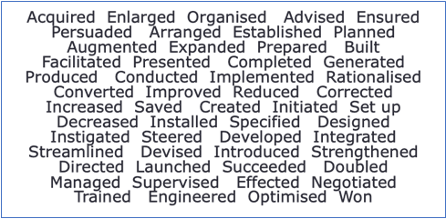

Activity 3: Seek feedback

Ask a friend who is not familiar with your research (and the world of research) to read your examples and feed back to you on:

* Whether they fully understood every word
* What they believe impact is: is it the message you wanted to get across?